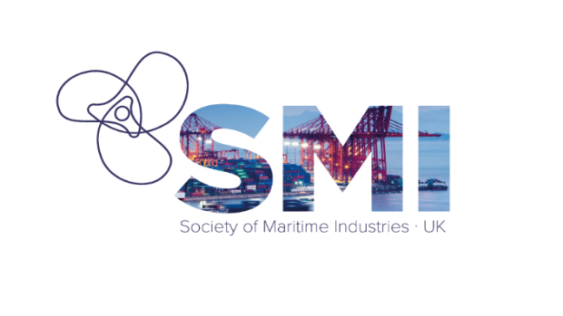
INDUSTRY ENGAGEMENT DAY AT PORT TALBOT
Monday 28th and Tuesday 29th November 2022
Please complete and return this registration form electronically by Monday 14th November to:
For all enquiries please contact Helen Stephen via:

Telephone: |  | +44 7391 827143 |  |  |  |  |  |  |  | E-mail: |  |  |  | helen.stephen@maritimeindustries.org
Company:
Address:
Town: |  |  |  |  | Post Code: |  |  |  |  |  |  |  | Country:
Phone No: |  |  |  |  |  |  | Mobile No:
E-mail:
The following wishes to be represented at the above event:
Name: |  |  |  |  |  |  |  |  | Position:
Name: |  |  |  |  |  |  |  |  | Position:
*Please delete where not applicable
*The company is a member of SMI. I wish to register __ person(s) (please indicate number attending)  OPTION 1 (subject to availability of accommodation) and accept the terms & conditions below.  I enclose payment of £275 + VAT (Total: £330) per person totalling:  *The company is NOT a member of SMI. I wish to register __ person(s) (please indicate number attending)  OPTION 1 (subject to availability of accommodation) and accept the terms & conditions below.  I enclose payment of £350 + VAT (Total: £420) per person totalling: |  |  |  |  |  |  |  |  |  |  |  |  |  |  |  | £
*The company is a member of SMI. I wish to register __ person(s) (please indicate number attending)  OPTION 2 and accept the terms & conditions below.  I enclose payment of £75 + VAT (Total: £90) per person totalling:  *The company is NOT a member of SMI. I wish to register __ person(s) (please indicate number attending)  OPTION 2 and accept the terms & conditions below.  I enclose payment of £125 + VAT (Total: £150) per person totalling: |  |  |  |  |  |  |  |  |  |  |  |  |  |  |  | £
*An invoice is requested which will be settled immediately on receipt. |  |  |  |  |  |  |  |  |  |  |  |  |  |  |  | *Yes/No
*I wish to pay by *AMEX / *MASTERCARD / *VISA card please contact me for card details. |  |  |  |  |  |  |  |  |  |  |  |  |  |  |  | *Yes/No
Signed: |  |  |  | Name: |  |  |  |  |  |  |  |  |  | Date:
Terms & Conditions for events organised by the Society of Maritime Industries, 28-29 Threadneedle Street, London, EC2R 8AY
- Subject to the prior agreement of the speakers, summaries of the presentations made will be available to delegates who attend, only after the event.
- Receipt by the Society of Maritime Industries of a properly completed booking form signed by a delegate is contractually binding irrespective of whether payment has been received. Where payment is not made by credit card at the time of receipt of the booking form by the Society of Maritime Industries, it must be made within 7 days of receipt of an invoice from the Society of Maritime Industries.
- Changes of delegate names can be made up to 15 full working days before the event but fees cannot be refunded for cancellations received after the registration deadline. Refund for bookings cancelled before expiry of the registration deadline will be limited to 50% of the fee.
- It may be necessary to amend the timings or parts of the programme but fees due cannot be refunded.
- If, for reasons beyond the control of the Society of Maritime Industries, it is necessary to cancel the event or postpone it to another date or venue, the fee paid will be held as a credit for the delegate’s attendance at future SMI events.
- The Society of Maritime Industries is not responsible for any loss or damage as a result of a substitution, alteration, postponement, or cancellation of the event due to causes beyond its control including but without limitation natural disasters, sabotage, accident, trade or industrial disputes or hostilities.
- Cost of travel to and from Swansea will be on your own account. Please note that SMI cannot reimburse travel costs in the event that the visit does not proceed.
- The numbers who can attend the visit are limited and places will be allocated strictly in the order in which registrations are received. SMI will need to receive a sufficient number of bookings for the visit to proceed.

